**Dashboard reports**

**What are Dashboard Reports?**

Dashboard reports are reports that display project data is tabular and graphic form. Each report displays different data and can be customized to tailor the reports for each users needs.

Below is a view of the Overallocated Resources Dashboard Report. Note that there are two charts each representing different resource data. The chart on the left represents Actual Work v Remaining Work. The chart on the right is displaying resources that are Overallocated at the day level. Each of these reports may be altered to adjust the chart type, chart elements and details of the display data.

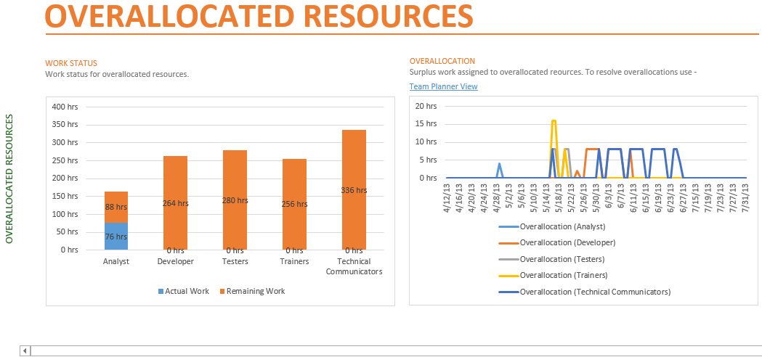

**Data included in the Dashboard Reports:**

Dashboard Reports contain data relating to project progress, variance calculations, and critical path. Below are listed some of the data which are included in the reports. If you are not using the data needed to populate the reports, the reports will not display properly.

Some of the data needed for the reports includes the following project data values:

* Task Duration, Cost and Work.
* Resource Cost and Work.
* Baseline comparison.
* Status date.
* Status field: Late, On Time, Future

**To Display a Dashboard Report:**

1. Click on the **REPORTS** tab
2. Click on a Report Category: **Dashboards, Resources, Costs, In Progress**
3. Click on a Report to display

To change parameter values displayed on a Dashboard Report:

1. Click on the **REPORTS** tab
2. Click on a Report Category: **Dashboards, Resources, Costs, In Progress**
3. Click on a Report to display
4. Click inside of a graph. Options will appear on the right side of the view.
5. Change options as necessary. Close by options by clicking on the X in the upper left corner of the options box.
6. Other changes may be made by clicking on formatting changes on the Design ribbon which will appear when a Report is selected.

**NOTE:** Changes to Dashboard Reports will be remembered within the file and will appear the next time the report is viewed.

**TIP:** Clicking on the **Page Breaks** button will display the page breaks as for printing the report. The separate report graphics and tables may be dragged to different pages for printing purposes.